**Lab 1:**

**First Order Circuit**

Name: Wan-Yu Liao

ECEN 325 Section 514

TA: Mandela

Lab Date: September 6, 2019

Lab Report Due Date: September 9, 2019

**Calculations**

In prelab part 1, I derived the transfer function and expressed ⍵L, ⍵H, KL and KH in terms of resistors and capacitors.

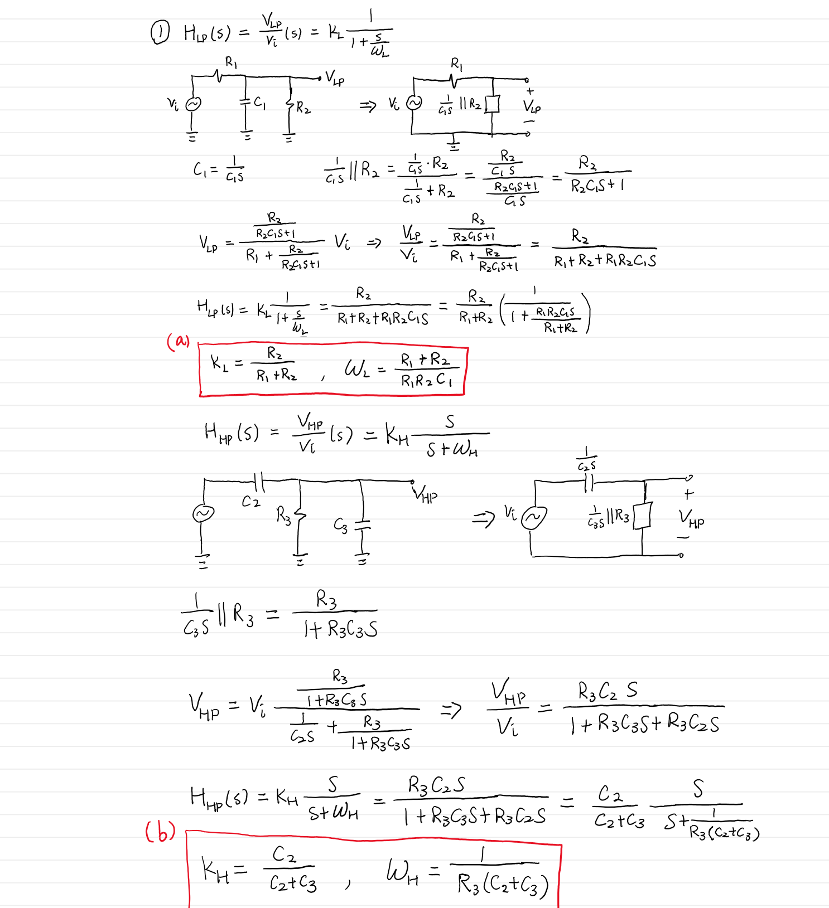

Then, I calculated the values of each resistors and capacitors.

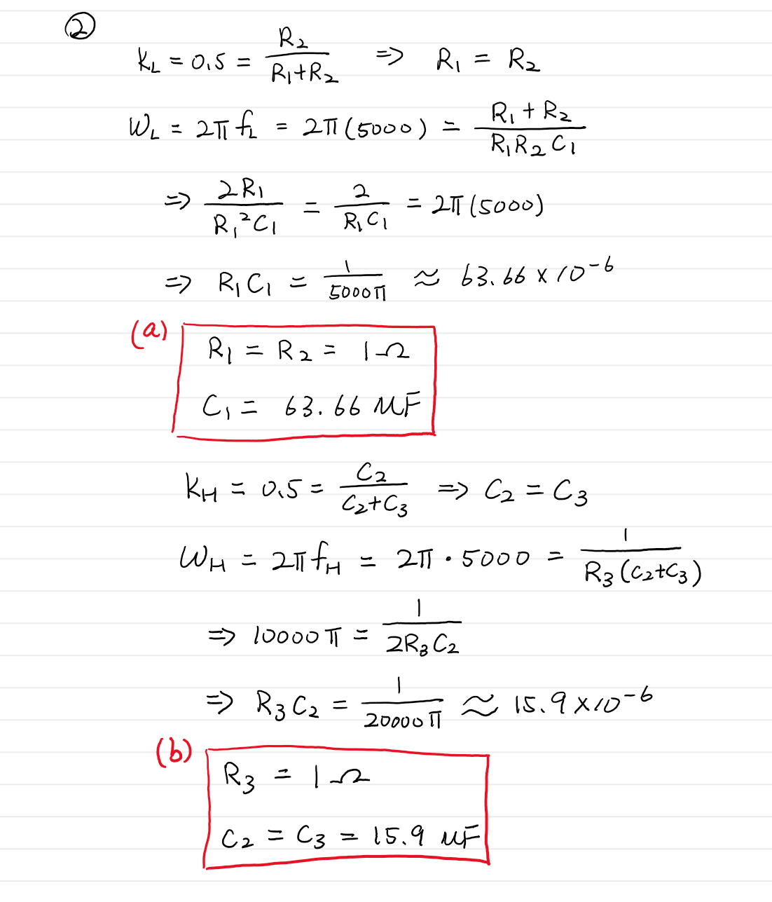

Next, I calculated the output voltages VLP(t) and VHP(t) for Vi(t) = 0.4 sin(2π4000t) and for Vi(t) = 0.3 sin(2π6000t)

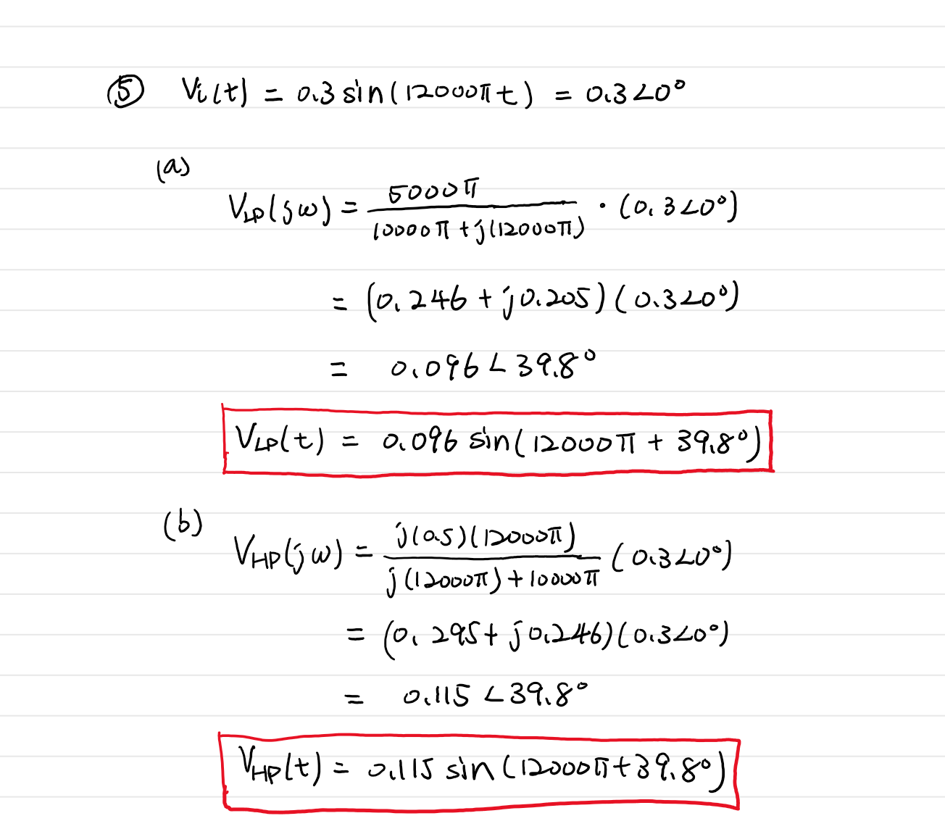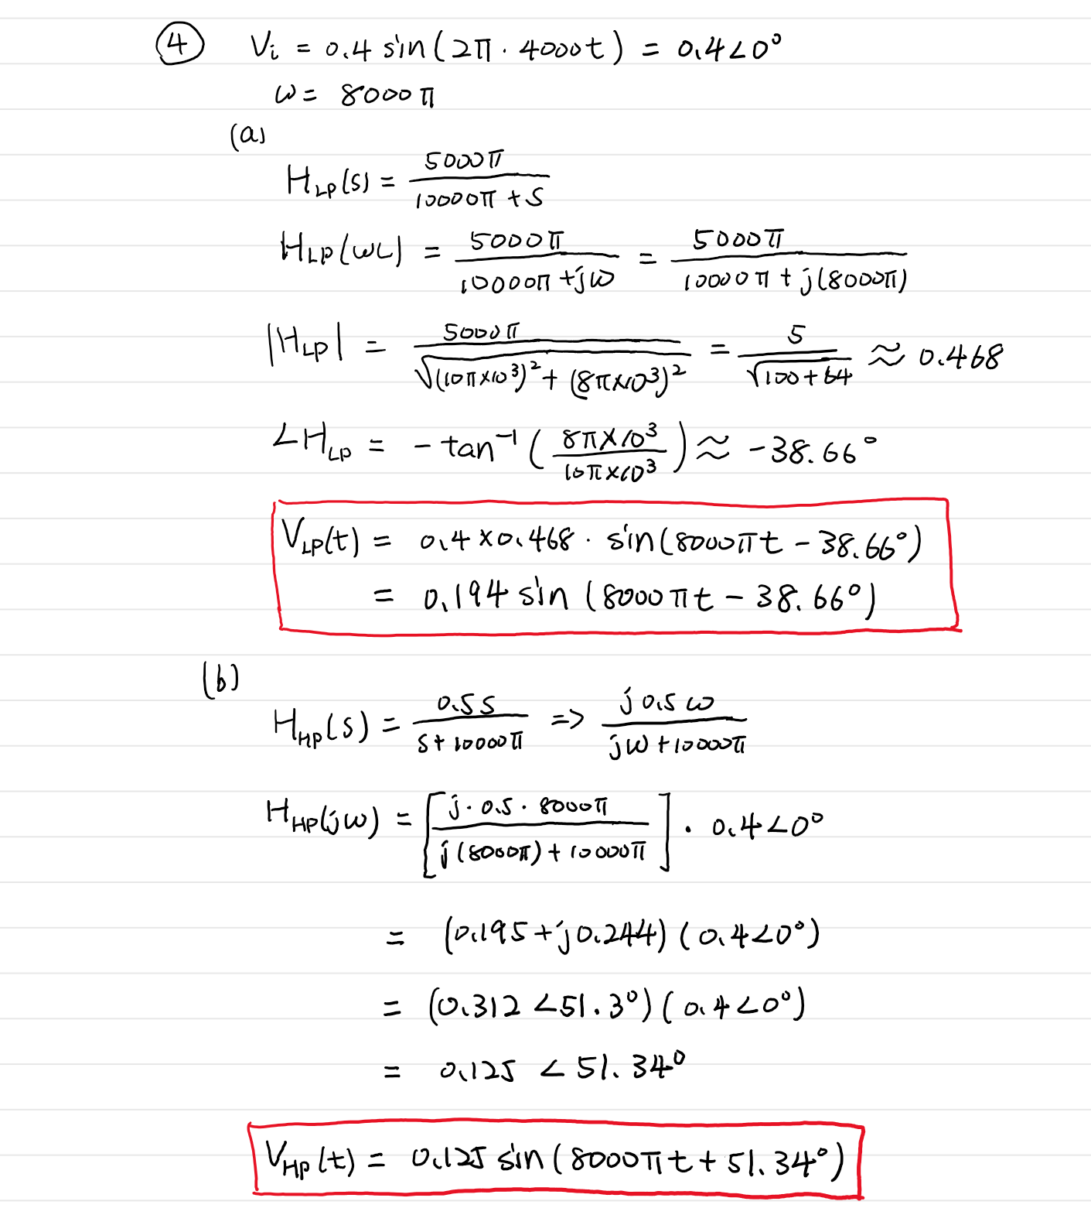

**Schematics**

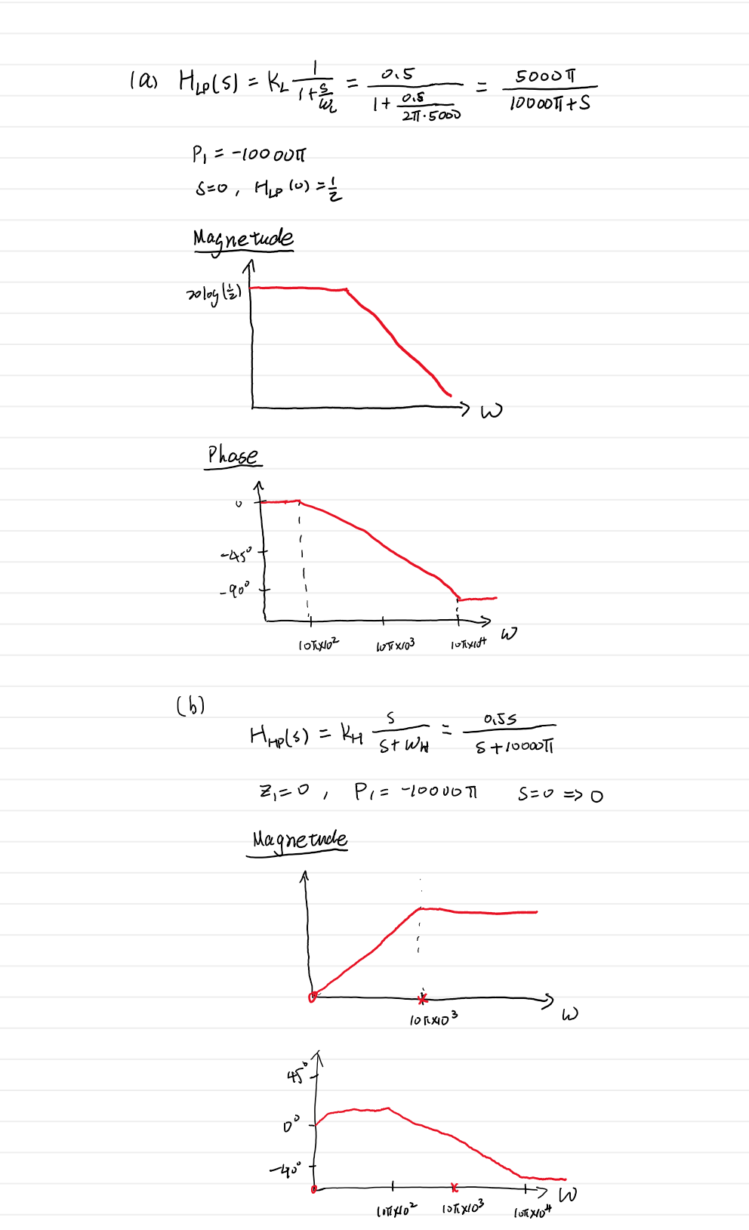

**Simulation Plots**

**Circuit a. Bode Plot**

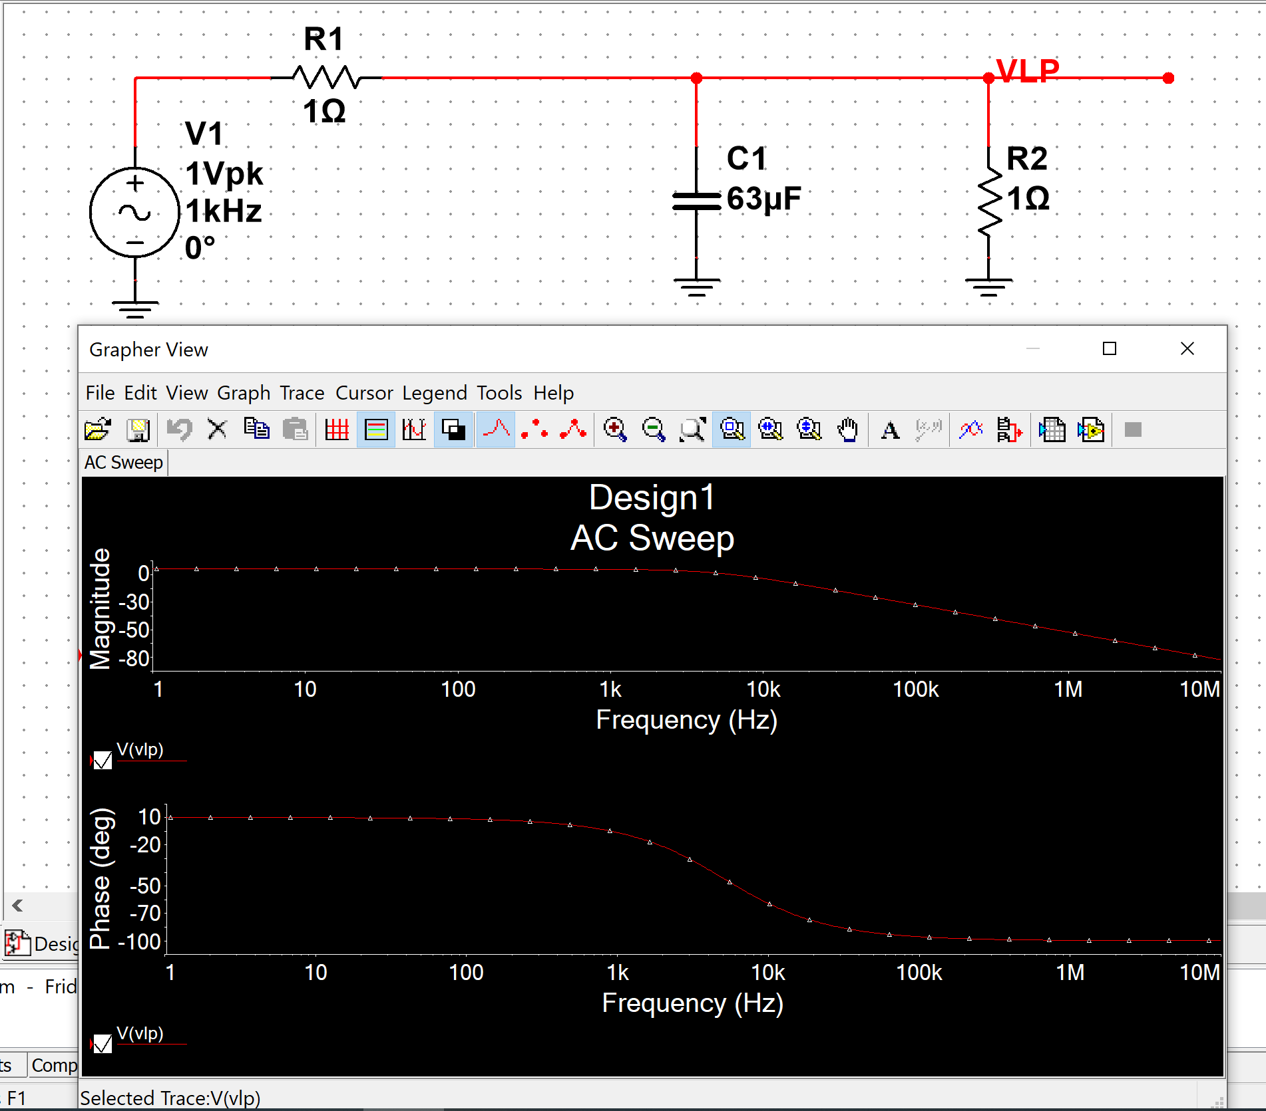

**Circuit b. Bode Plot**

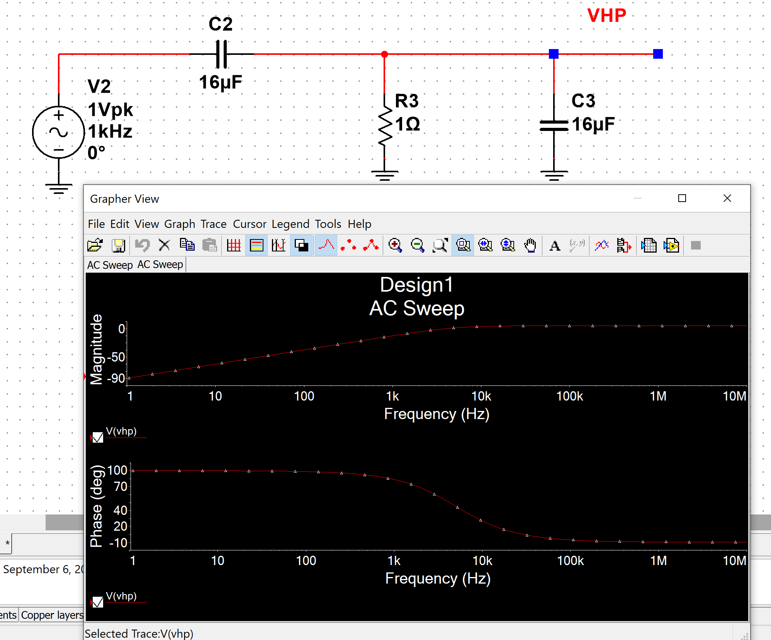

**Circuit a. with Vi(t) = 0.4 sin(2π4000t)**

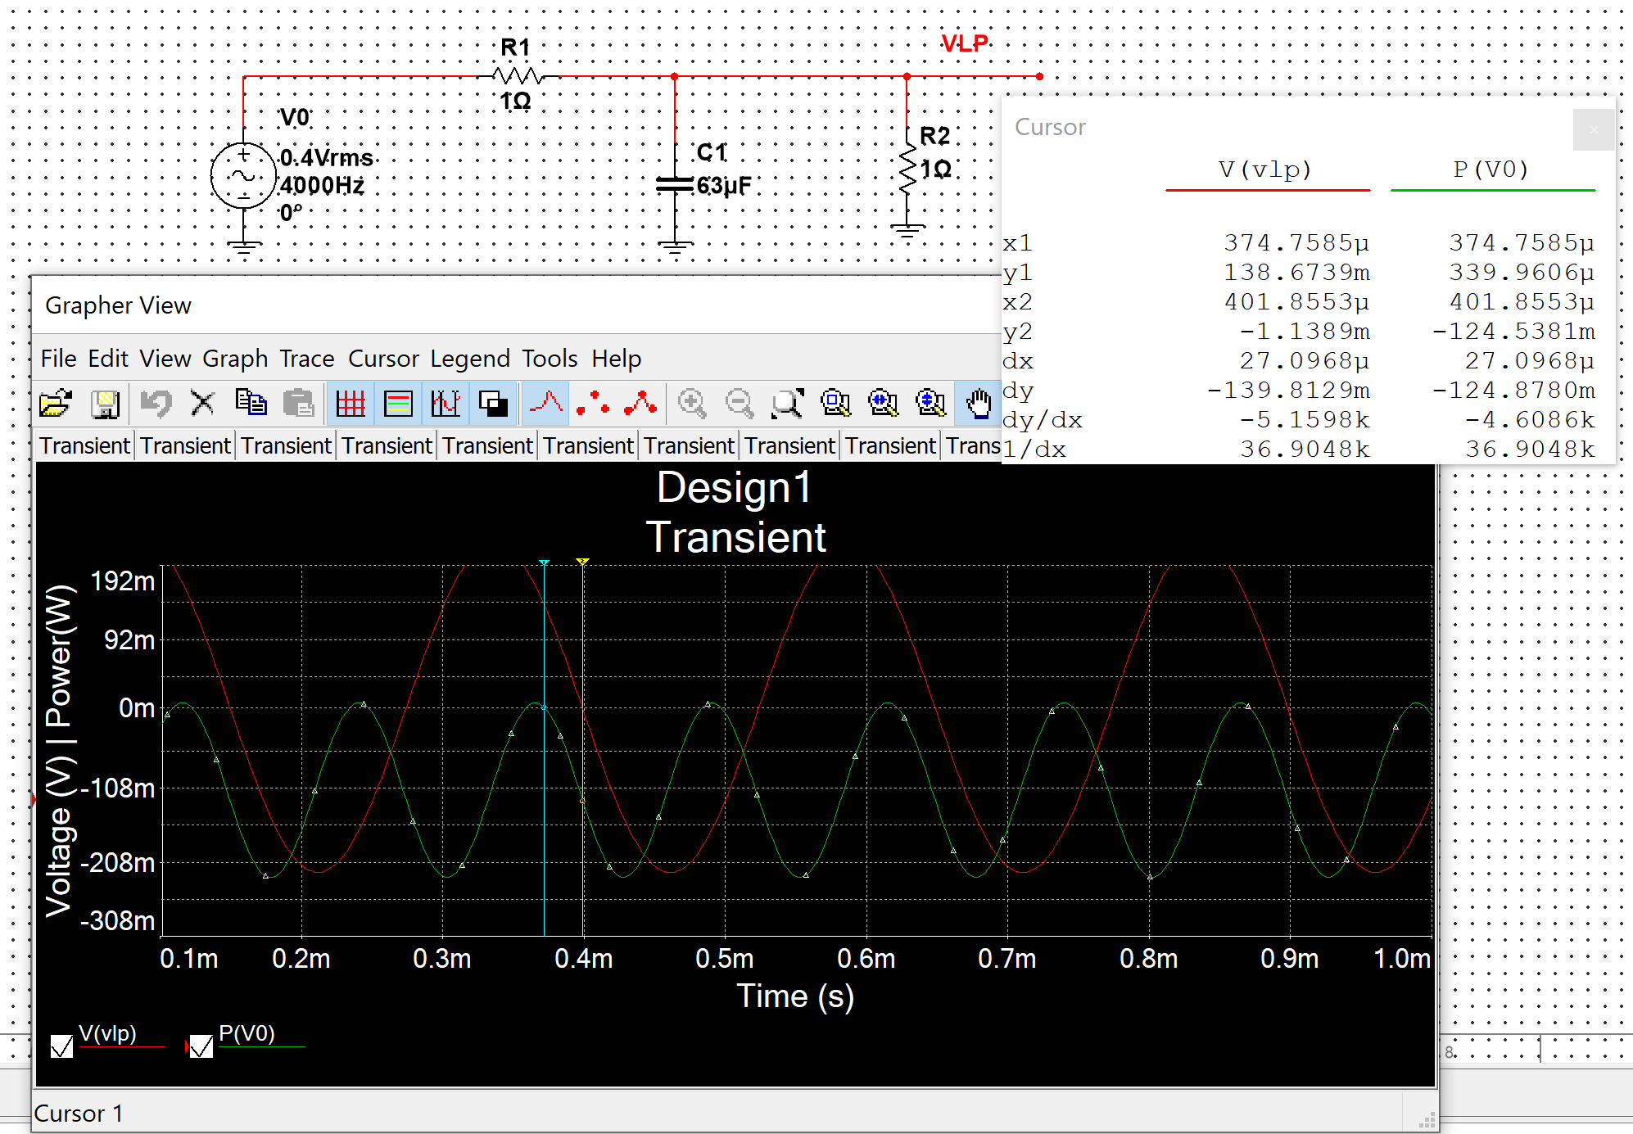

**Circuit b. with Vi(t) = 0.4 sin(2π4000t)**

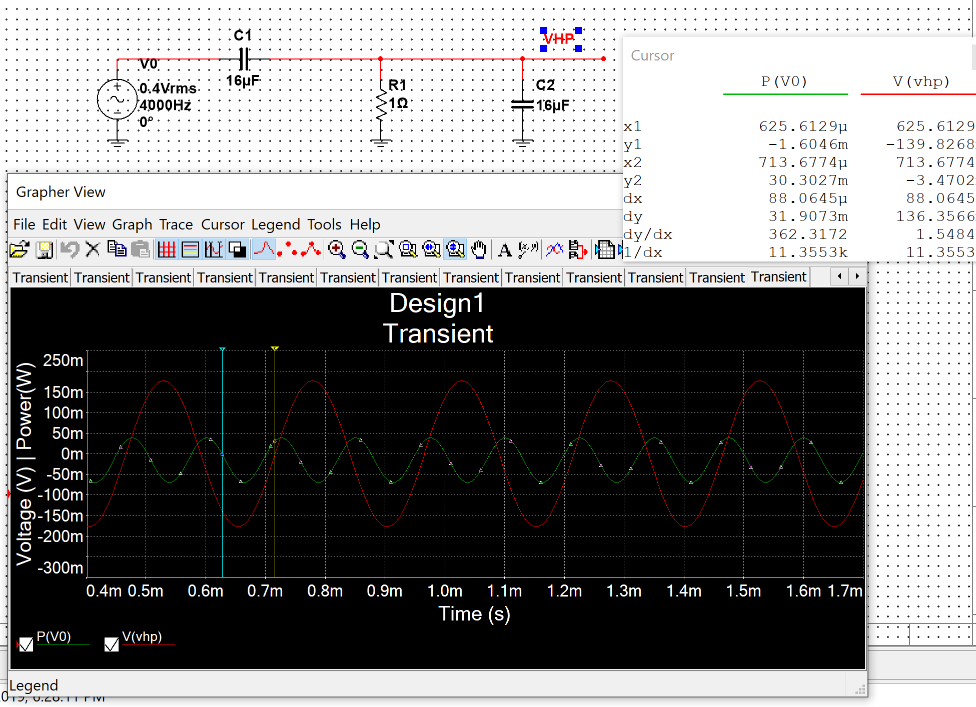

**Circuit a. with Vi(t) = 0.3 sin(2π6000t)**

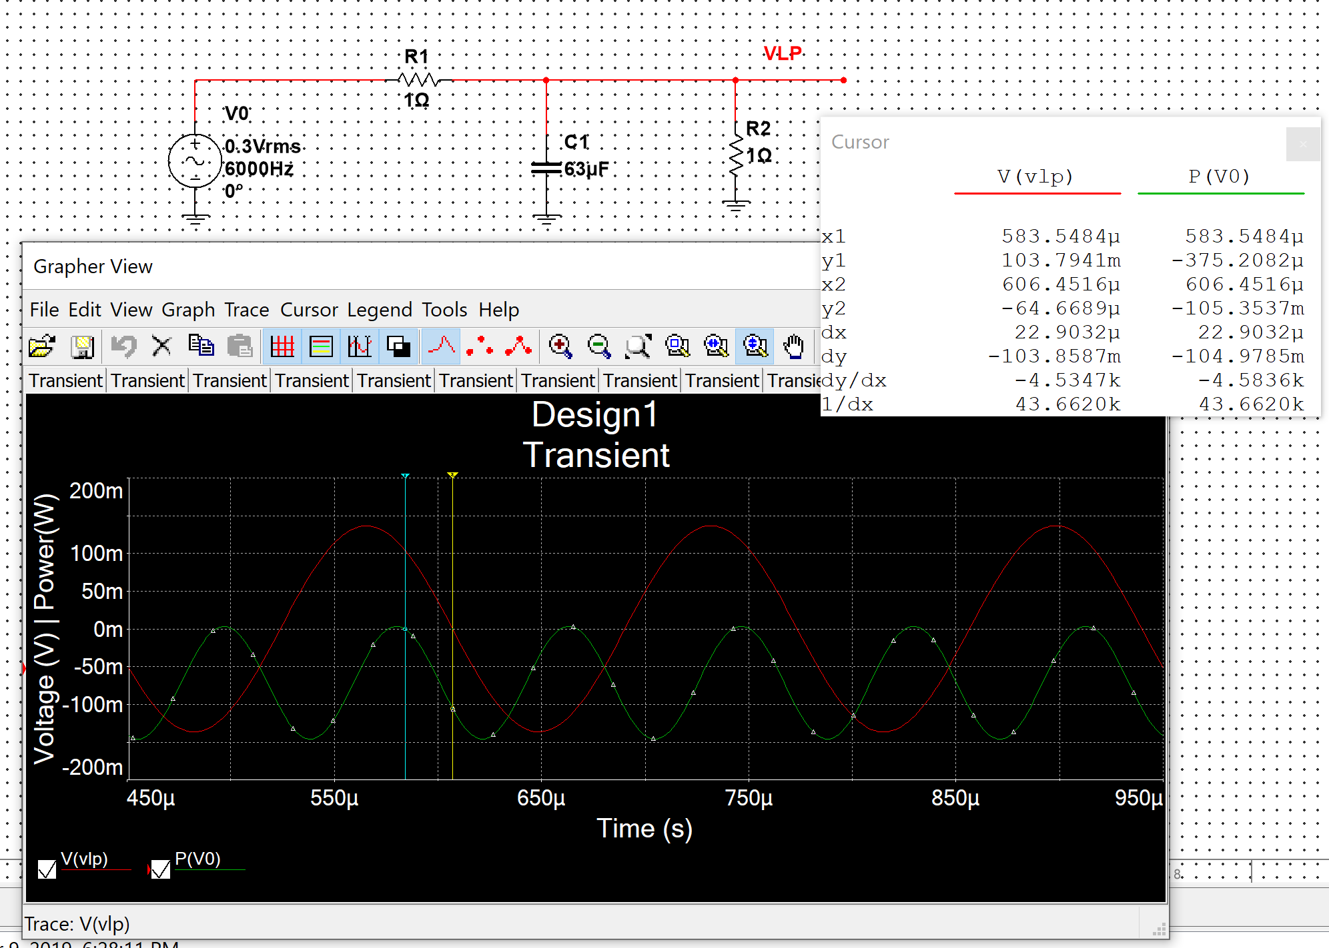

**Circuit b. with Vi(t) = 0.3 sin(2π6000t)**

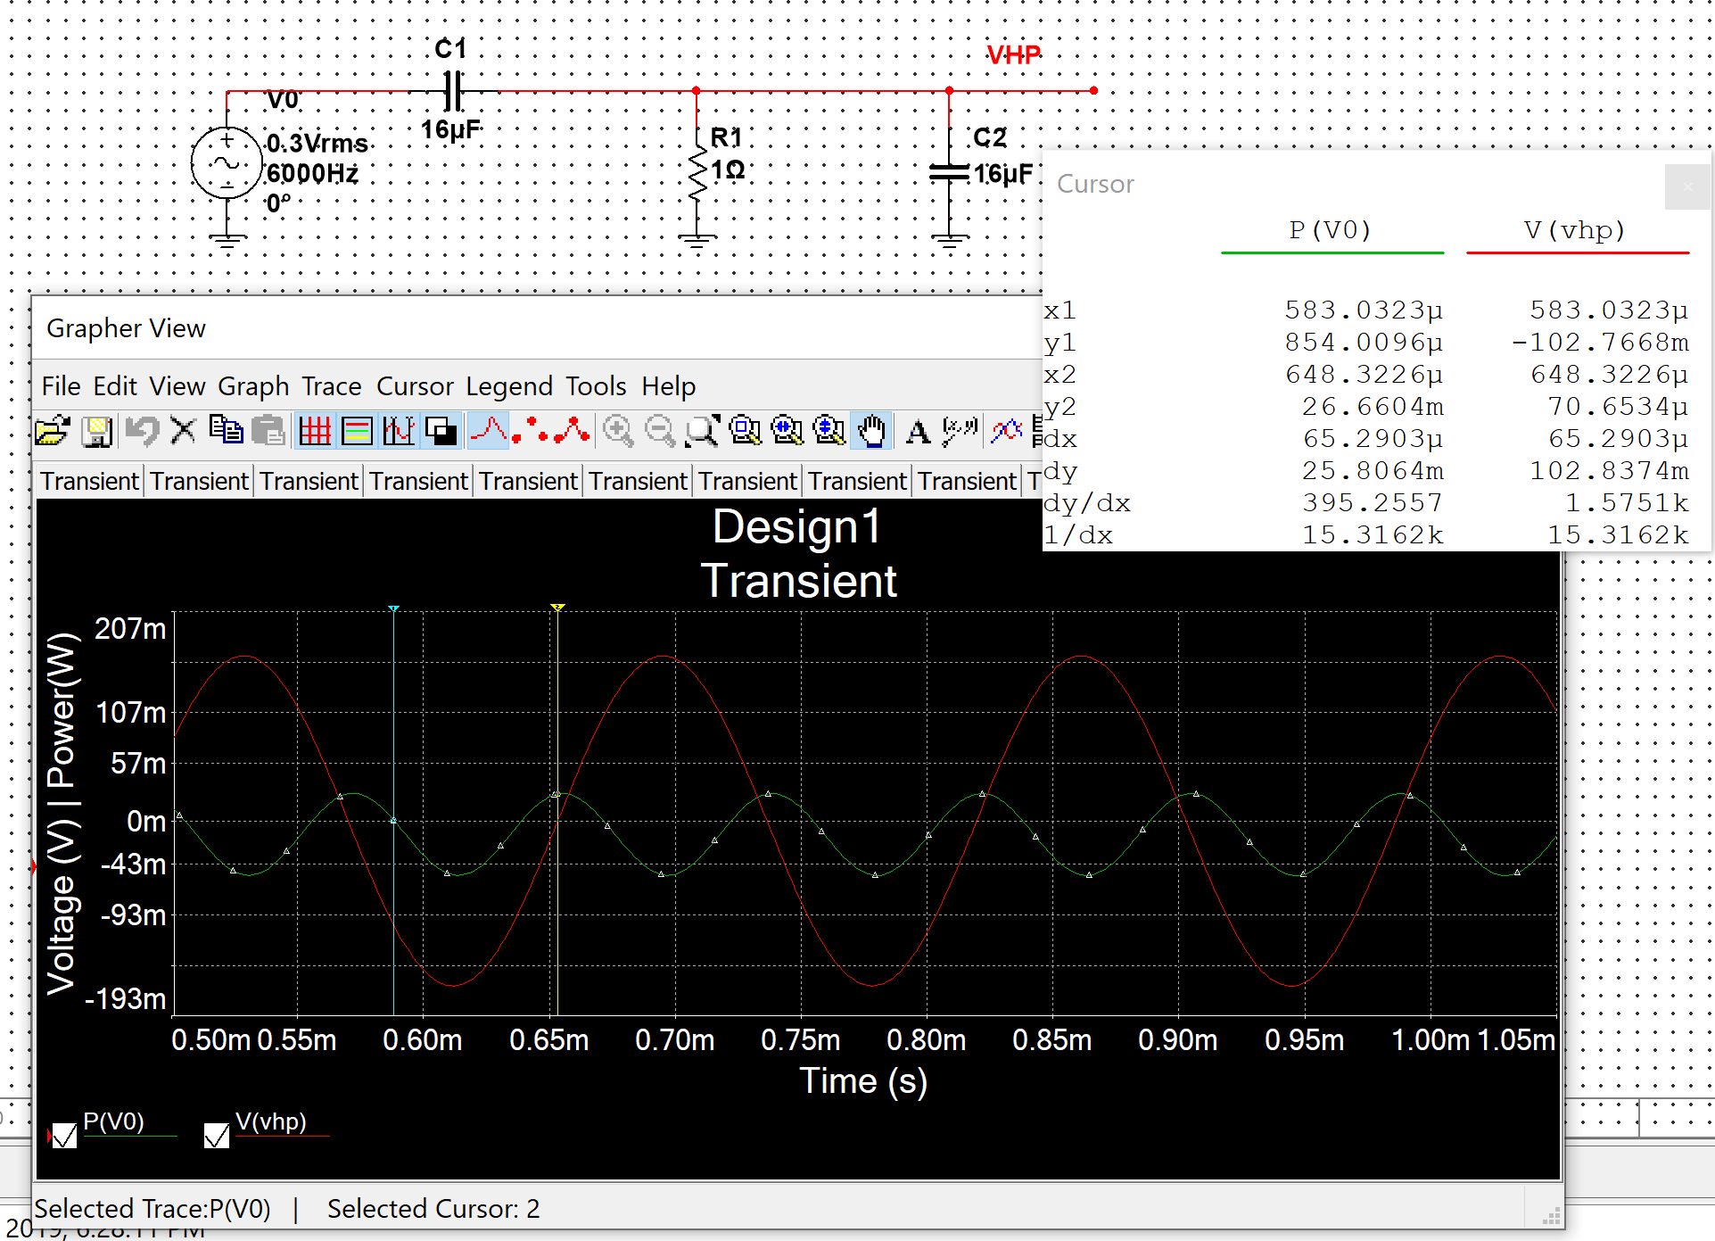

**Measurement Plots**

**Circuit A.**

**Bode Plot**

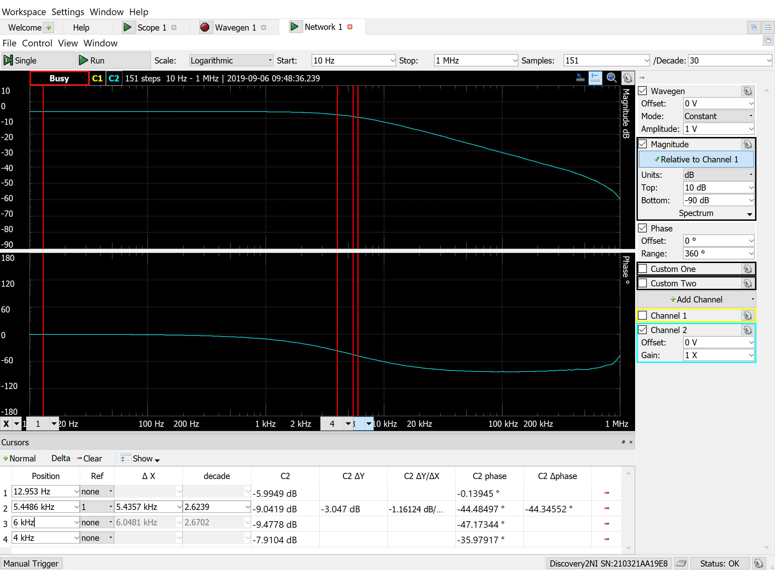

**Vi(t) = 0.4 sin(2π4000t)**

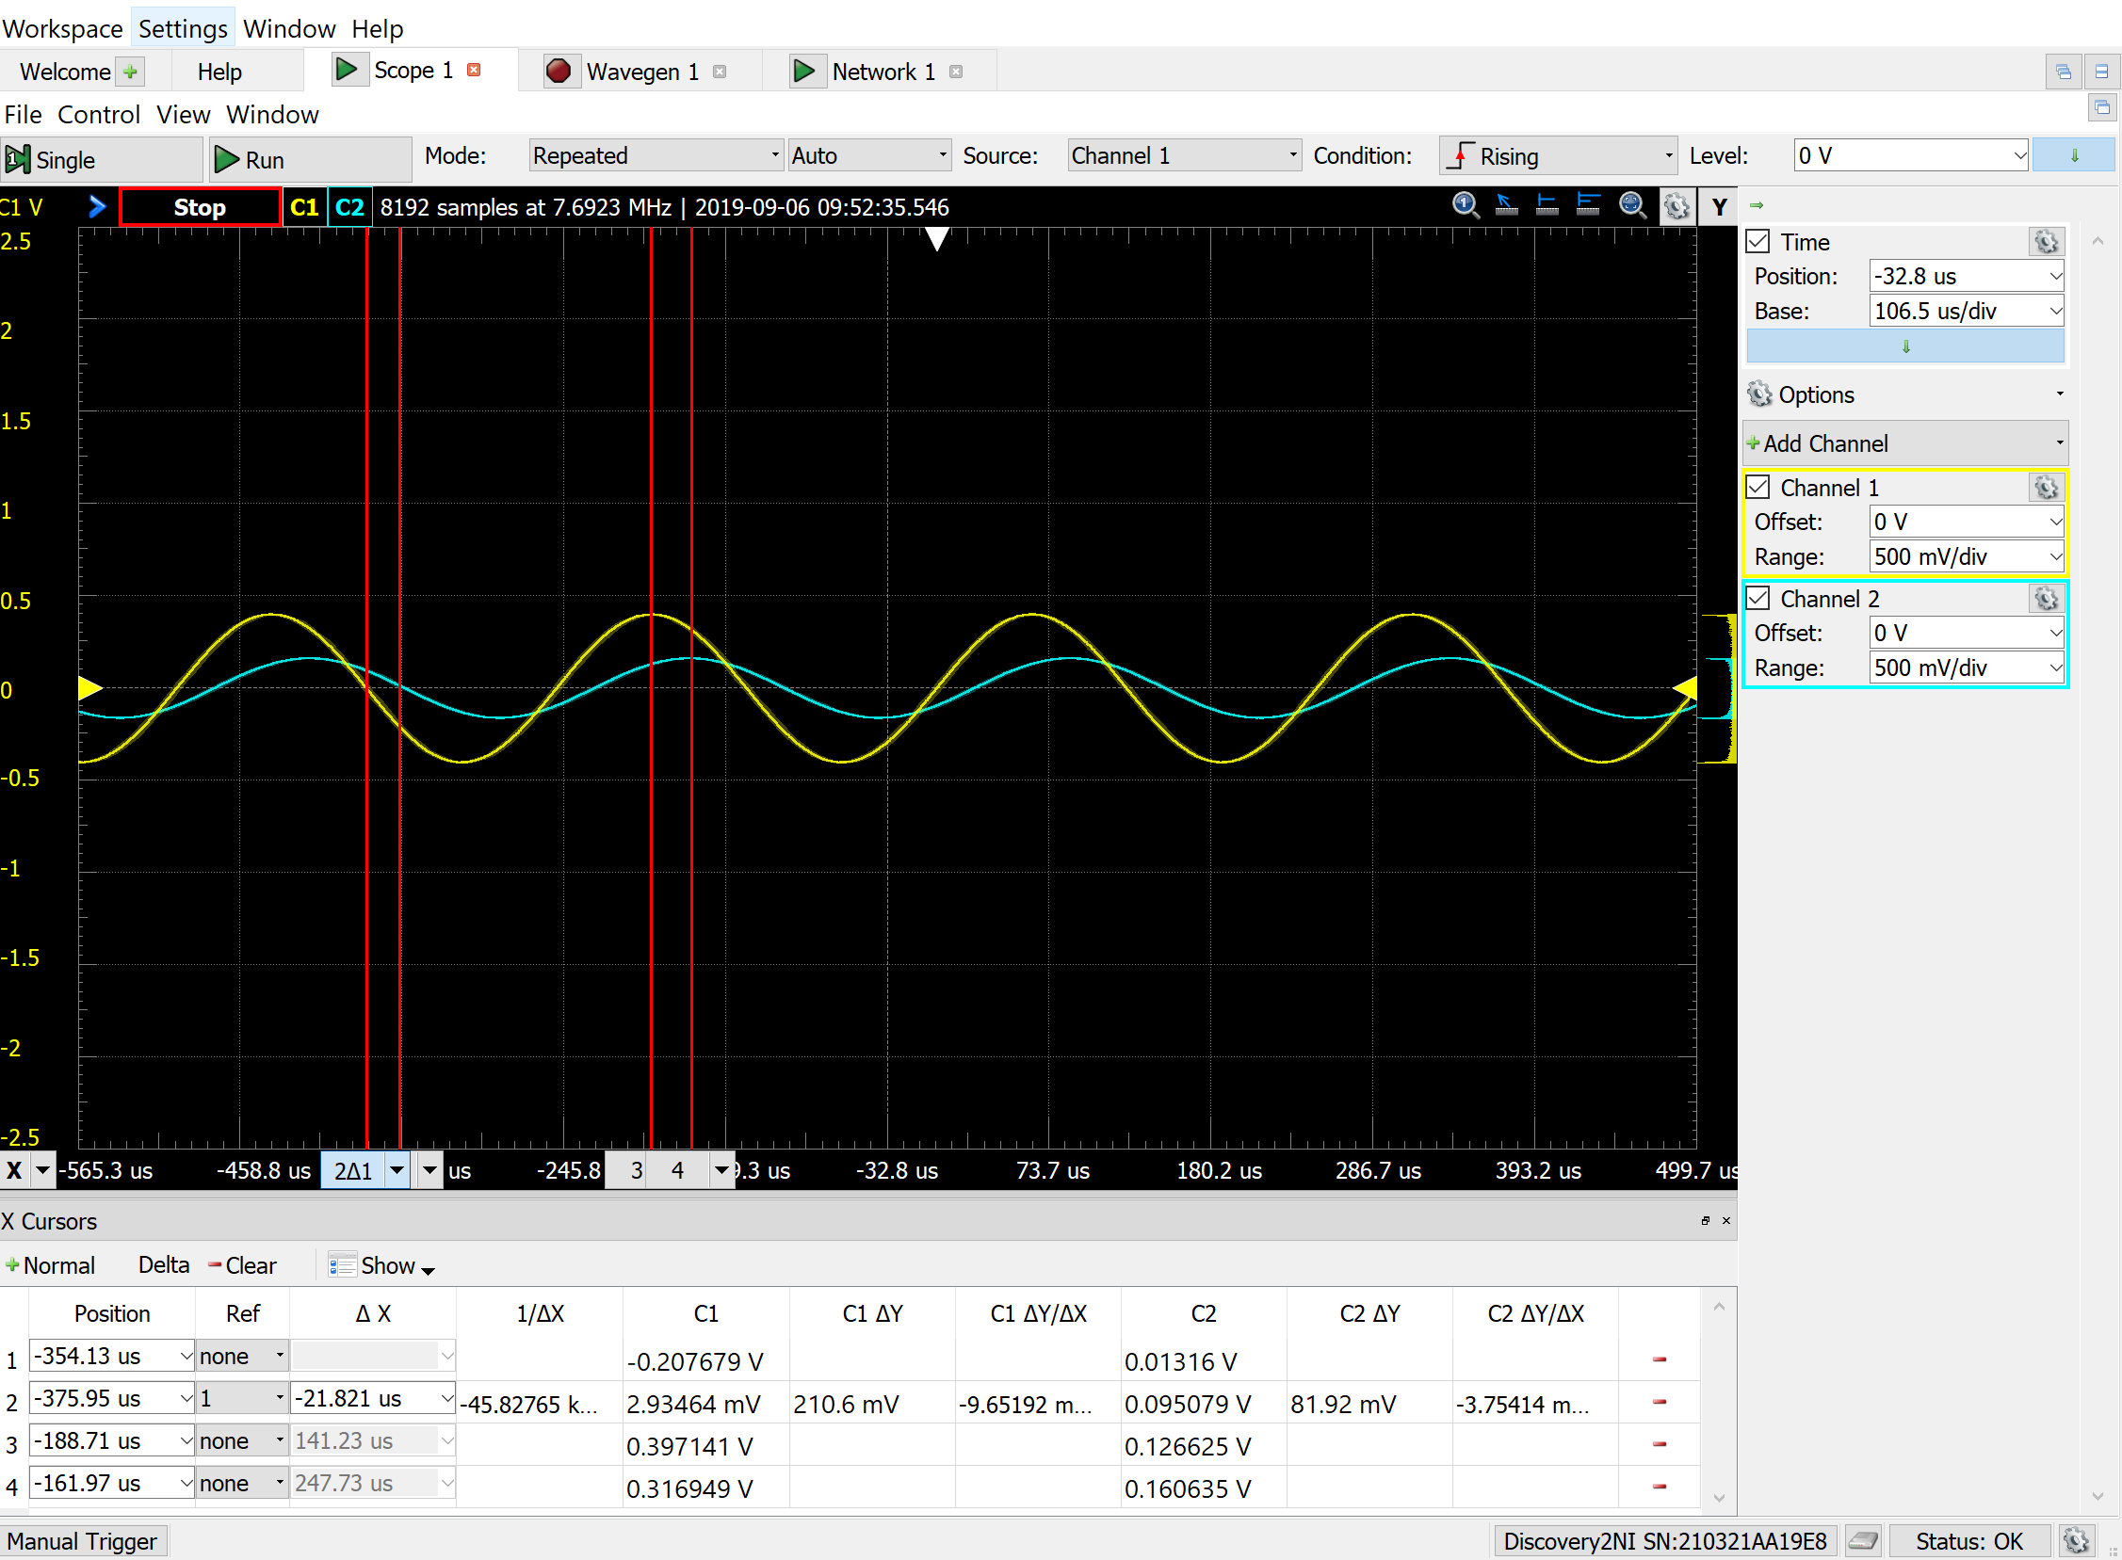

**Vi(t) = 0.3 sin(2π6000t)**

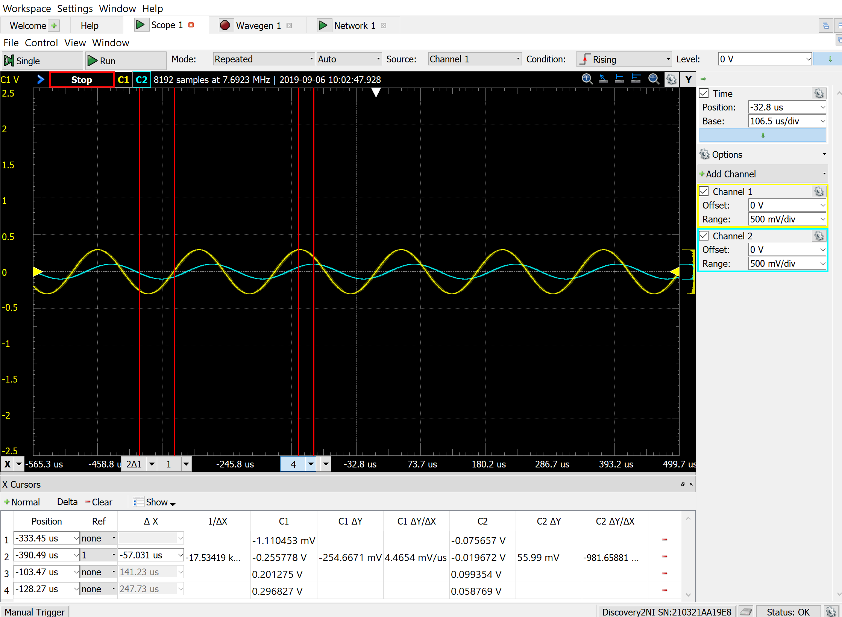

**Circuit B.**

**Bode Plot**

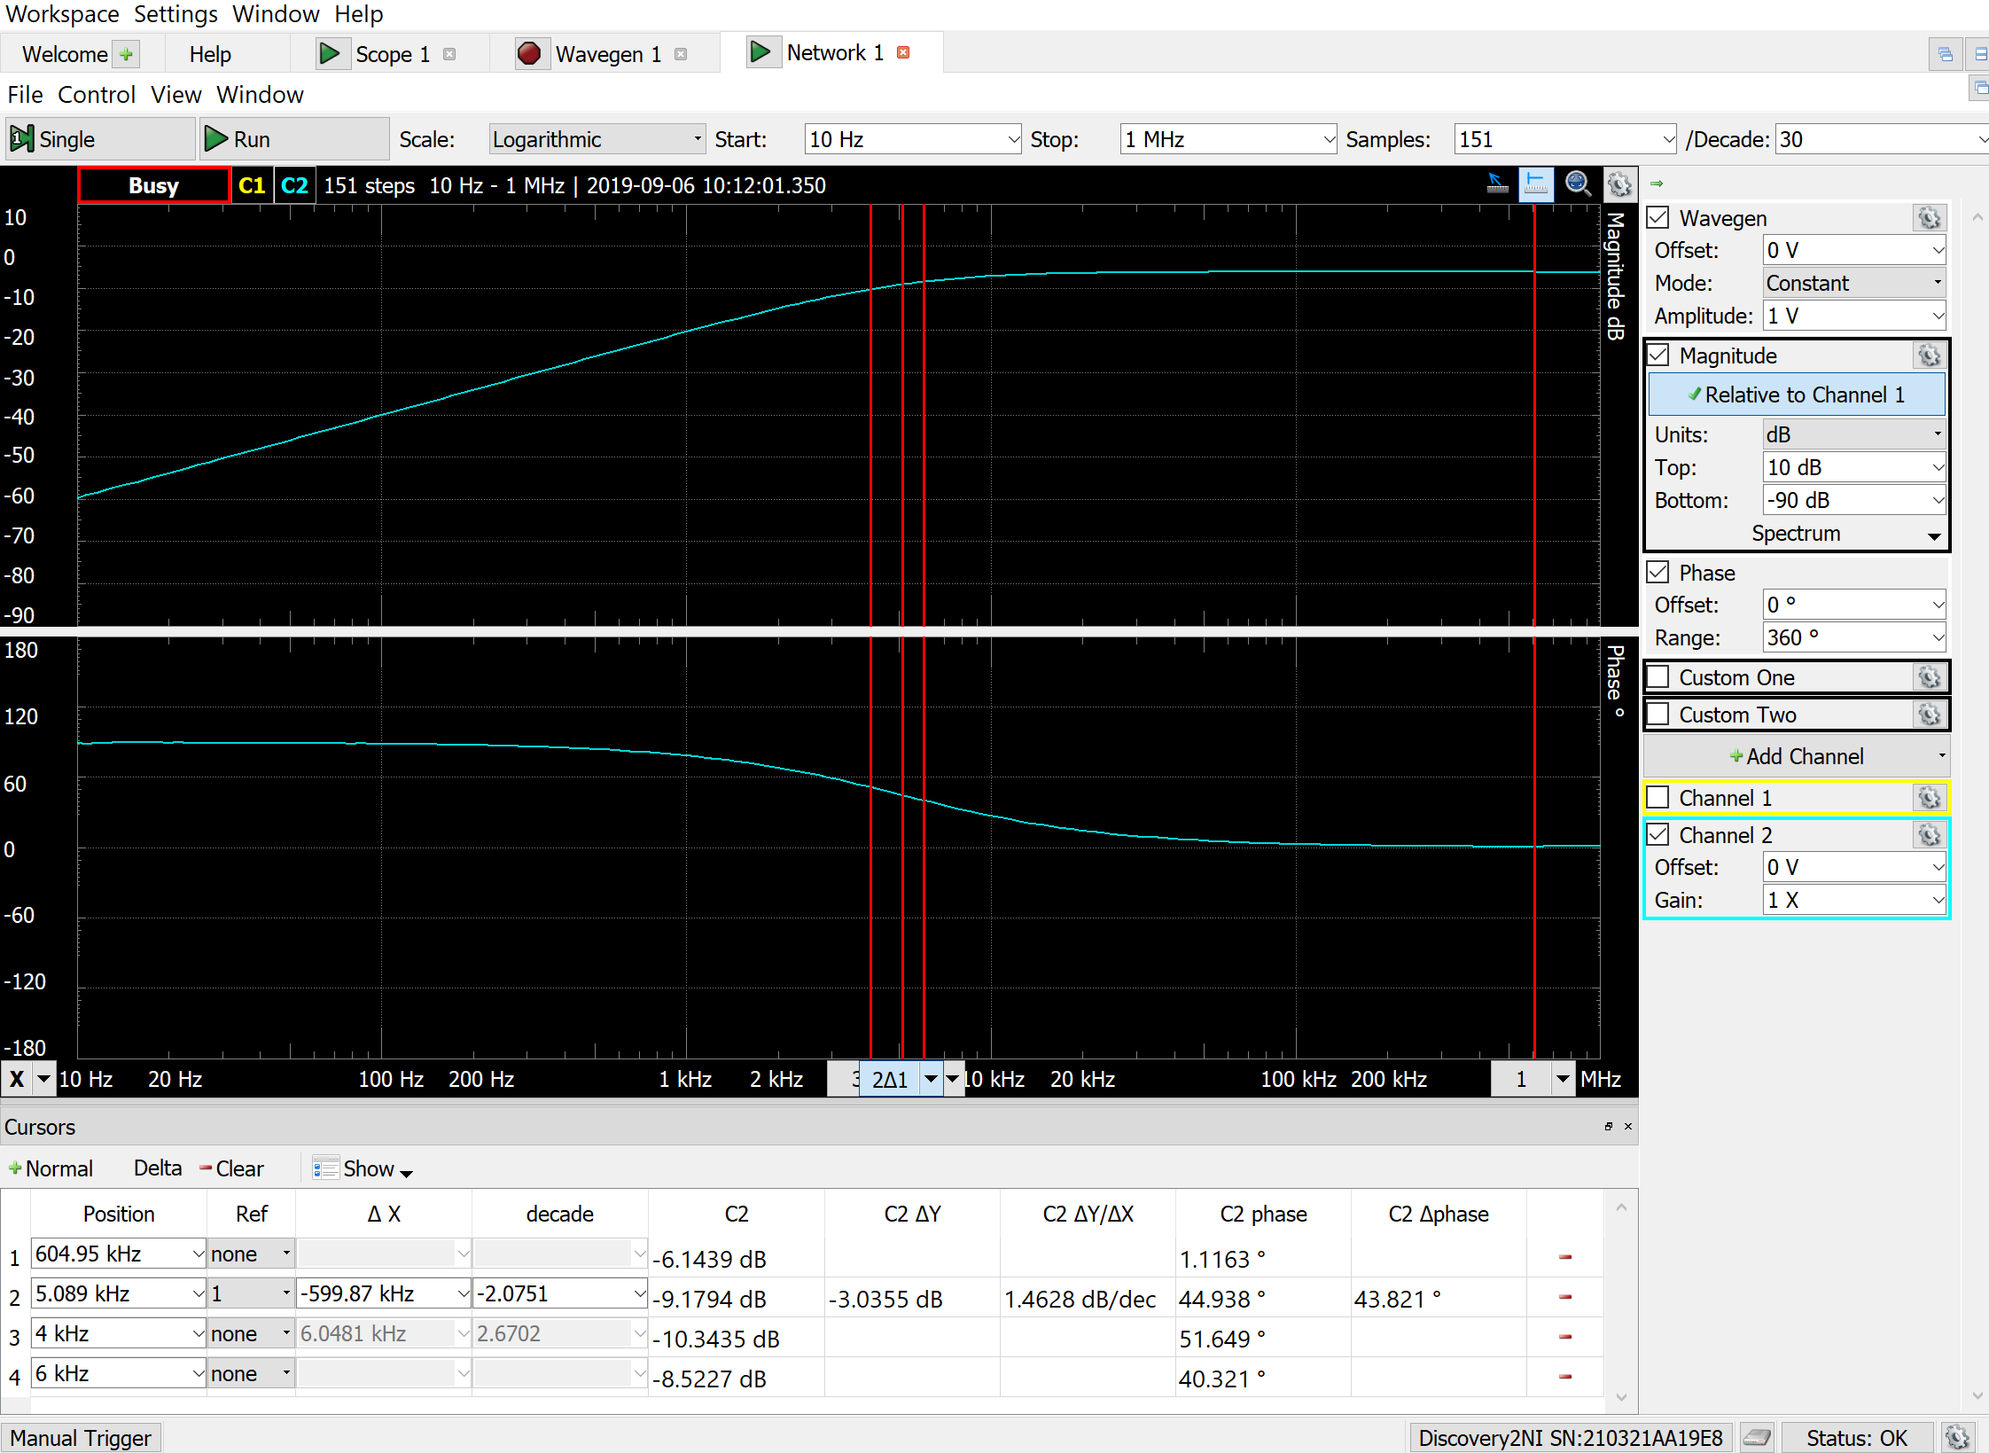

**Vi(t) = 0.4 sin(2π4000t)**

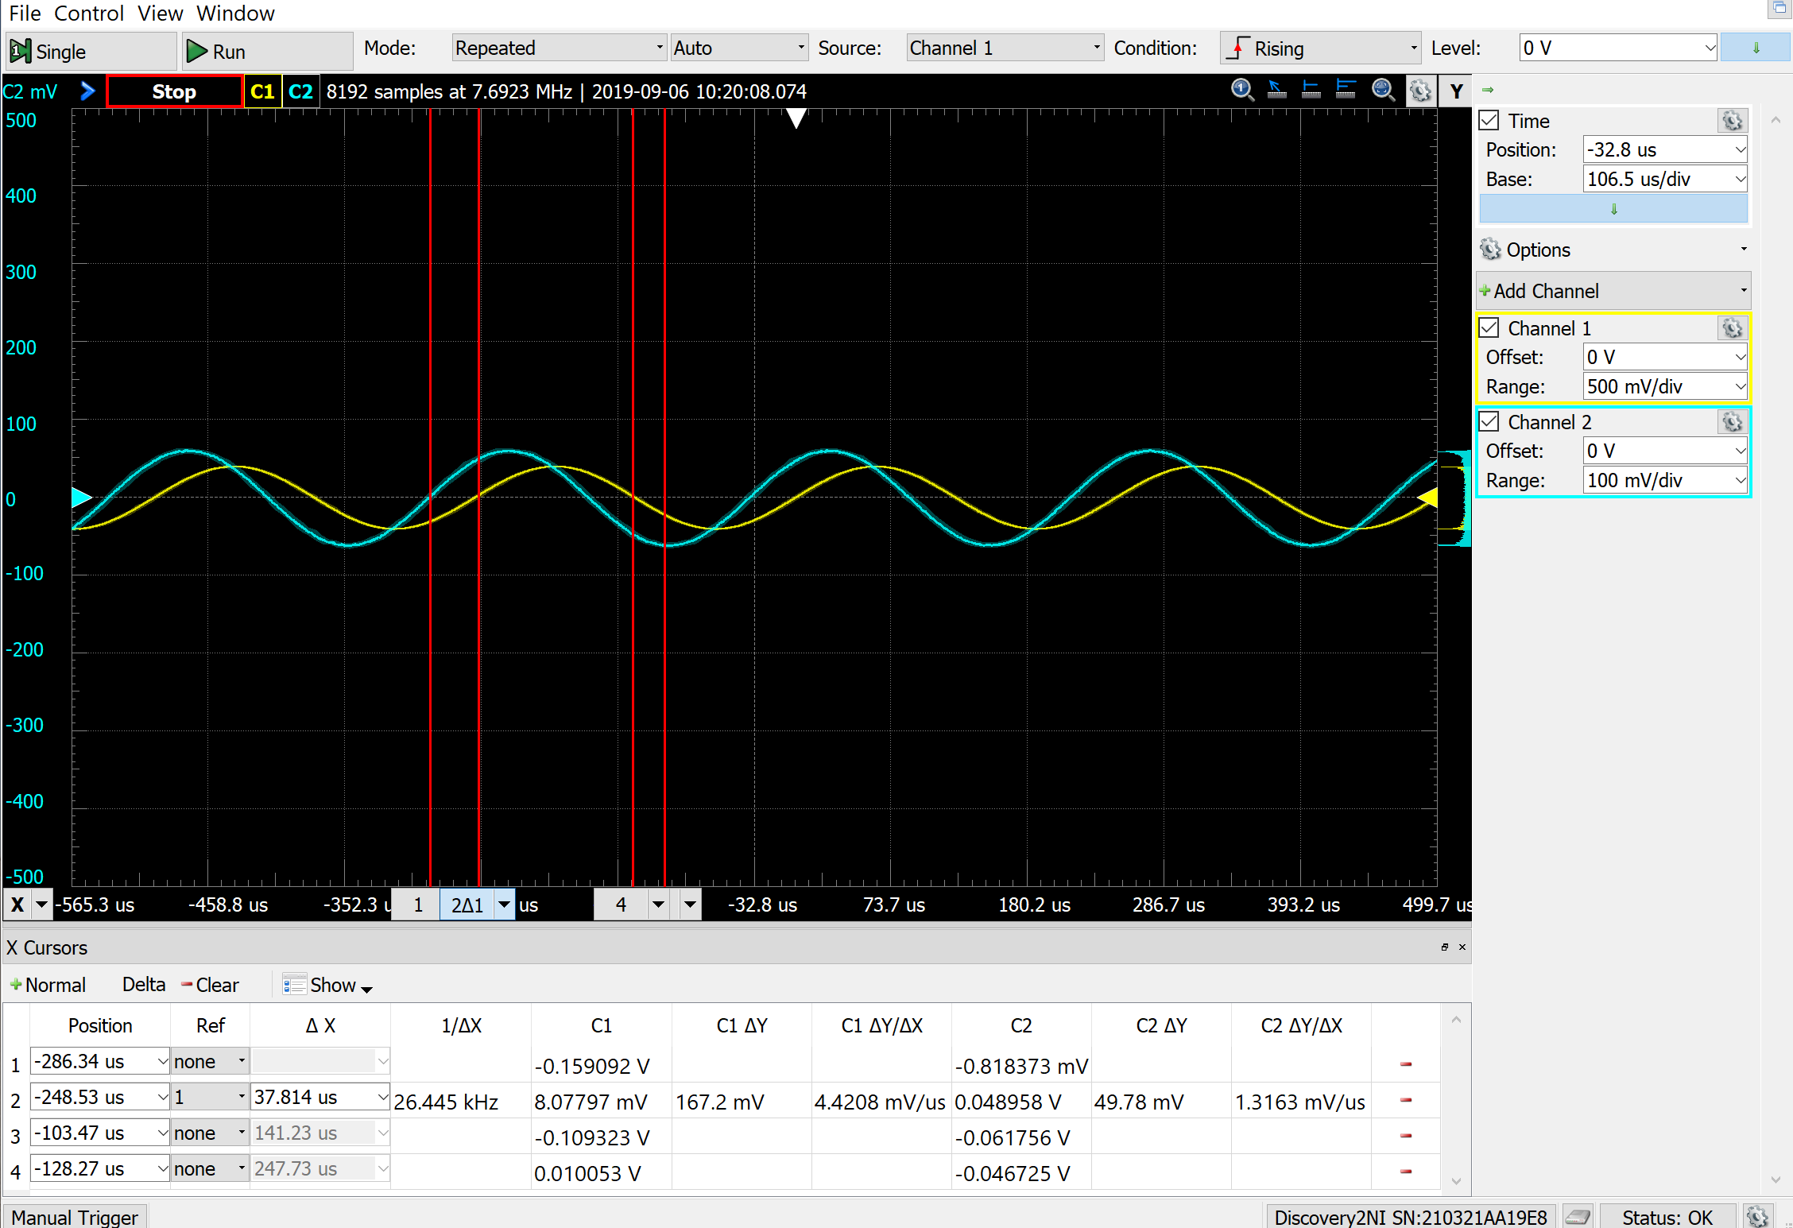

**Vi(t) = 0.3 sin(2π6000t)**

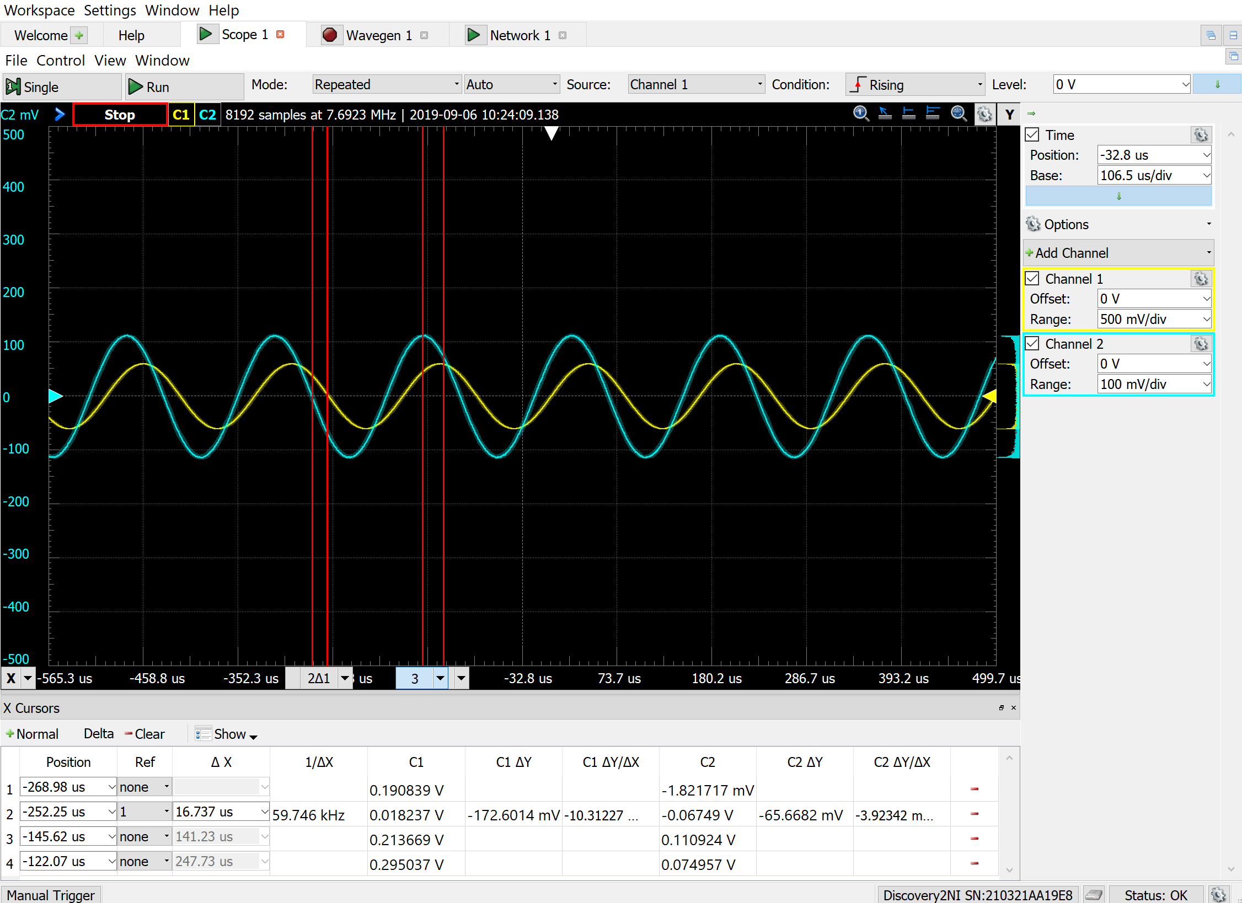

**Table**

**For Vi(t) = 0.4 sin(2π4000t)**

|  |  |  |  |  |
| --- | --- | --- | --- | --- |
|  | frequency | Time diff. (us) | ∠H | |H| |
| Calculate Circuit A | 4k | N/A | -38.66° | 0.194 |
| Calculate Circuit B | 4k | N/A | 51.34° | 0.125 |
| Simulation Circuit A | 4k | 27.1 | 27.1e-6*4k*360 = **39.0°** | 0.222/0.00646 = 34.1 |
| Simulation Circuit B | 4k | 88.1 | 88.1e-6*4k*360 = **126.8°** | 0.177/0.038 = 4.66 |
| Measurement Circuit A | 4k | -21.8 | -21.8e-6*4k*360 = **-31.4°** | 0.397/0.161 = 2.46 |
| Measurement Circuit B | 4k | 37.8 | 37.8e-6*4k*360 = **54.4°** | -0.109/-0.046 = 2.37 |

**For Vi(t) = 0.3 sin(2π6000t)**

|  |  |  |  |  |
| --- | --- | --- | --- | --- |
|  | frequency | Time diff. (us) | ∠H | |H| |
| Calculate Circuit A | 6k | N/A | 39.8° | 0.096 |
| Calculate Circuit B | 6k | N/A | 39.8° | 0.115 |
| Simulation Circuit A | 6k | 22.9 | 22.9e-6*6k*360 = **49.5°** | 0.136/0.0032 = 42.5 |
| Simulation Circuit B | 6k | 65.3 | 65.3e-6*6k*360 = **141°** | 0.163/0.027 = 6.04 |
| Measurement Circuit A | 6k | -57 | -57e-6*6k*360 = **-123.1°** | 0.297/0.099 = 3.0 |
| Measurement Circuit B | 6k | 16.7 | 16.7e-6*6k*360 = **36.1°** | 0.295/0.111 = 2.66 |

**Comment**

For calculation results and simulation results, I used resistors, R1 = R2 = R3 = 1Ω, and capacitors, C1 = 63.66μF and C2 = C3 = 15.9μF. However, for measurement results, I used resistors, R1 = R2 = R3 = 1kΩ, and capacitors, C1 = 63.66nF and C2 = C3 = 15.9nF.

For both circuits, the calculation, simulation, and measurement values of |H| and ∠H are a lot different except for Vi(t) = 0.4 sin(2π4000t) circuit A. For the calculation part, I think this is due to my calculation errors and for the simulation part, I think I have the wiring problems and placing the output voltage the wrong way that caused the output and input time-domain waveforms look weird.